Instagram Engagement Analysis: Post Performance on @dataanalystduo
INTRODUCTION
This report presents a data-driven analysis of the engagement patterns associated with various post types on @dataanalystduo's account. By leveraging data analytics, the goal is to design an interactive dashboard that provides clear insights into how different post categories—such as images, videos, carousels, and stories—perform in terms of likes, comments, shares, and other relevant engagement metrics. These insights will help in refining content strategies, enhancing audience interaction, and driving better outcomes for the account's growth and reach.
OBJECTIVE
1) Analyse Total Reach, Followers' Visits, and New Followers: Track visibility and growth through reach, follower visits, and new follower acquisition.
2) Map Top Cities and Countries: Visualize the geographic distribution of the audience to target key regions for better engagement.
3) Examine Age and Gender Distribution: Understand the demographic profile of followers by age and gender for tailored content creation.
4) Identify Common Keywords: Analyse popular keywords and hashtags to refine content strategy and boost engagement.

DATA CLEANING AND PREPARATION
1) There are seven datasets: Reach, Profile Visits, New Followers, Content, Age & Gender, Top Cities, and Top Countries.
2) The Reach and Profile Visits datasets start from January 2022, while the New Followers and Content datasets begin in December 2022. For a comprehensive, data-driven analysis, we have used data starting from December 2022 onward.
3) In the Reach, Profile Visits, and New Followers datasets, the date and time were combined in a single column. We separated the time from the date and removed it. In a new sheet, we consolidated the three datasets and calculated the day based on the respective dates.
4) The conversion rate was calculated using the formula:
New Followers ÷ Reach
The growth rate was calculated using the formula:
(Current Day's New Followers ÷ Previous Day's New Followers) - 1
Note: Unfollows were not considered.
5) In the Content Data Sheet, we calculated the following metrics:
(i)Duration Bins: Posts were categorized into three groups—“30 Secs,” “11-30 Secs,” and “>30 Secs”—to understand viewer engagement.
(ii)Engagement Rate: It means how users interacting with content. It was calculated using the formula:
Average of (Shares ÷ Reach, Likes ÷ Reach, Comments ÷ Reach, and Saves ÷ Reach).
(iii)Retention Rate: It means users who continue using a product over time. This was calculated using the formula:
3-second views ÷ Reach.
ANALYSIS AND INSIGHTS

1) Men dominate younger age groups (18-34) – The majority of the population is men, especially in the 25-34 age group, where they significantly outnumber women.
2) Women peak in the 25-34 group – This is the only category where women have a notable presence, though still fewer than men.
3) Drastic decline in older groups (35+) – Both men and women sharply decrease beyond 35, with minimal representation in older age brackets.
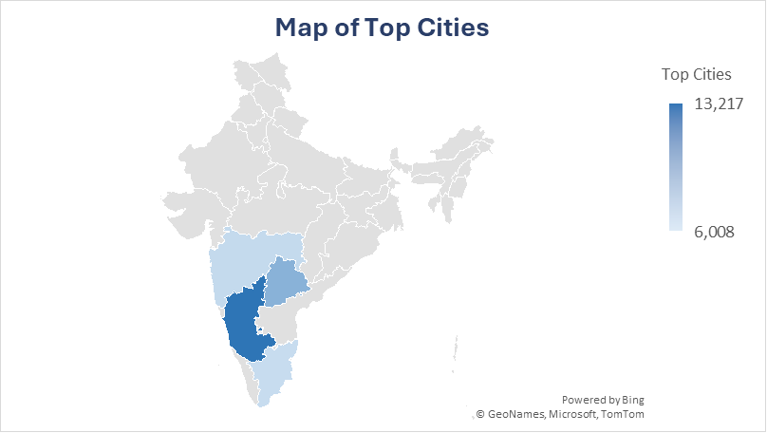
1)Bangalore Leads in Audience Size
With 13,217 individuals, Bangalore has the highest engagement, indicating it as a key hub for the audience. Content and marketing strategies should be tailored to resonate with Bangalore-based users.
2)Majority Audience Concentrated in South & West India
Cities like Hyderabad, Chennai, Mumbai, and Pune show high engagement, suggesting that South and West Indian regions have a strong presence in the audience. Regional trends, language preferences, and city-specific interests can be leveraged.
3)Mumbai and Chennai Show Similar Engagement Levels
Mumbai (7,076) and Chennai (6,942) have nearly equal audience size, suggesting balanced engagement across these two metro cities. Any targeted campaigns should consider these cities as equally significant.
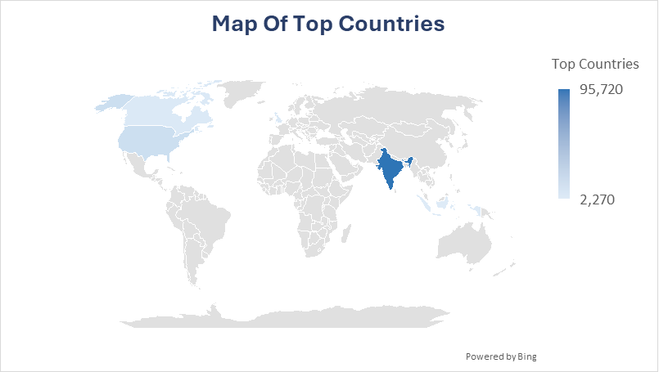
1)India Dominates the Audience (95,720 users)
A massive 81% of the audience is from India, making it the primary target market for content, campaigns, and engagement strategies.
2)United States is the Second Largest Market
With 11,748 users, the US represents the biggest non-Indian audience, suggesting an opportunity to expand globally with region-specific content.
3)Potential Growth in Canada, UK & Indonesia
Canada (3,605), the UK (3,605), and Indonesia (2,270) show moderate engagement, meaning localized efforts (content timing, cultural relevance) could improve reach in these regions.
Impression | Top 5 Keywords
>100K | data, sql, statistics, datascience, dataanalytics
50-100K | data, dataanalystduo, datascience, dataanalytics, sql
<50K | data, statistics, dataanalystduo, dataanalytics, datascience

- "Data" is the Most Consistently Used & High-Impact Keyword

- The keyword "data" appears in all impression categories, indicating its strong relevance and contribution to visibility.
- This suggests that content related to data-driven topics has a higher likelihood of gaining impressions.

- "SQL" Drives Higher Impressions (>50K)

- The keyword "SQL" is present in the >100K and 50-100K categories but is missing in the <50K category.
- This implies that posts featuring SQL-related content tend to perform better, making it a valuable topic to focus on.

- "DataAnalystDuo" Gains Traction in Mid & Lower Impression Ranges

- The hashtag "dataanalystduo" appears in 50-100K and <50K categories but not in the >100K group.
- While it helps with branding, it might not be as effective in boosting impressions beyond 100K. Optimizing the use of high-performing keywords alongside branding can enhance reach.
- Reels Have the Highest Retention & Conversion Rates
- Reels show a 54% retention rate, while carousels and images have 0% retention (suggesting users don’t stay on them for long).
- Reels also drive the highest conversion from reach to followers (0.38%), making them the most effective for audience growth.
- Carousels & Reels Drive the Same Engagement Rate (2.8%)
- Both carousels and reels have a 2.8% engagement rate, meaning they perform similarly in terms of likes, shares, and comments.
- Despite zero retention, carousels are still engaging, likely due to their educational or interactive nature.
- Single Images Perform the Worst
  - IG images have the lowest engagement rate (1.2%) and conversion rate (0.06%), making them the least effective post type.
  - This suggests that focusing more on Reels & Carousels instead of standalone images could improve overall engagement and growth.
- Mid-Length Videos (11-30 Secs) Have the Highest Retention (61%)
- Posts in the 11-30 sec range have the highest retention rate (61%), meaning users stay engaged the longest.
  - This suggests that shorter, yet information-packed videos hold attention better than very short or very long content.

- Longer Videos (>30 Secs) Drive the Best Engagement (3.41%) & Conversion (0.41%)
  - Despite a slightly lower retention rate than 11-30 sec videos, >30 sec videos generate the highest engagement and conversion rates.
  - This implies that longer, high-value content encourages interaction and follower growth.

- Very Short Videos (≤10 Secs) Have the Lowest Engagement (2.07%)
  - While they still retain attention (34%), posts under 10 seconds struggle with engagement and conversion.
  - This suggests that super-short content may not be as effective in building meaningful interactions compared to slightly longer formats.
RECOMMENDATIONS
- Leverage Regional Audience Strengths
Conclusion: The majority of the audience is concentrated in India, especially in Bangalore, Hyderabad, Mumbai, Chennai, and Pune. This suggests a strong regional interest in data-related content.
Recommendation: Create localized content tailored to the preferences of Indian audiences, such as case studies, industry trends, and job market insights relevant to these cities.
- Prioritize Video Content, Especially Reels
Conclusion: Reels outperform all other post types in retention, engagement, and follower conversion. Longer videos (>30 secs) drive the highest engagement (3.41%), while mid-length videos (11-30 secs) retain users the longest (61%).
Recommendation: Focus on creating engaging, information-packed Reels that are at least 30 seconds long to maximize reach, retention, and follower growth.
- Optimize Keyword Strategy for Higher Impressions
Conclusion: Keywords like "data" and "SQL" drive the highest impressions, whereas "DataAnalystDuo" helps with branding but is not as effective in reaching >100K impressions.
Recommendation: Use a mix of high-performance keywords (data, SQL, data science, analytics) along with branded hashtags to balance reach and brand identity.
- Refine Content Strategy for Maximum Engagement
Conclusion: Reels and Carousels have the highest engagement rates (2.8%), while single-image posts perform the worst (1.2%). This indicates that users prefer interactive or visually engaging content over static images.
Recommendation: Shift focus from single-image posts to Reels and Carousels. Experiment with different formats, such as storytelling Reels, interactive Carousels, and educational snippets, to boost engagement further.

